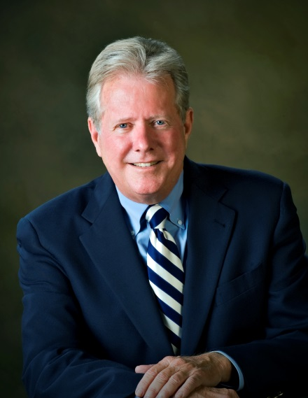
Jason Steele

www.smithlawtlh.com

321-258-8993 Cell

321-676-5555 Office

jasonsteele@me.com

SMITH & ASSOCIATES
1499 S. HARBOR CITY BLVD., STE. 202
MELBOURNE, FL 32901

Former FL State Representative
Real Estate Broker Court Appointed Receiver Television Executive Producer Expert Witness
Law Office Director of Government Affairs

Professional Experience
2015: Appointed by to Senate President Andy Gardiner Enterprise Florida Board of Directors A not-for-profit government and business partnership to guide Florida's economy.

2015: Appointed by Senate President Andy Gardiner to Space Florida Board of Directors A aerospace economic development organization, committed to attracting and expanding the next generation of space industry businesses in Florida.

2012 to Present: Director of Governmental Affairs for Smith & Associates Law Offices A non-lawyer and sole advisor on political matters for the firm’s offices in Melbourne and Tallahassee. Head of business development and provider of expert witness testimony in the on Real Estate matters in State and Federal Courts.

1990 to Present: Expert Witness: Retained for legal opinion on real estate cases in the state of Florida.

2013 to 2014: Court Appointed Receiver for the Hampton Inn of West Melbourne, FL
Strong Receivership skills have been recognized by the Circuit Court many times. Responsible for overseeing the staff and daily operations while making much needed improvements to insure occupancy, profitability and the maintaining of the Hilton flag while the property was undergoing lengthy court proceedings. Previously a Receiver in a highly visible Brevard Builders case in which he was able to save many homeowners from major losses, due to corruption of the builders. Prior receiverships also encompass apartments’ hotels, and residential subdivisions

2012 to Present: Executive Producer of TV Show “Political Food for Thought” Currently in its 5th season this show is a fast moving, non-partisan, non-adversarial cross between CNN News, and the Cooking Channel. It has been wildly successful in Florida airing on Fox Affiliate, Sun Sports, and is broadcast to 7,000,000 homes statewide in Florida.

2012 to Present: Broker for Jason Steele Real Estate
Jason entered the real estate business in 1972, became a broker in 1974 and Co-Founder Steele Realty, Inc owned by his longtime partner, and bother, Val Steele. Steele Realty, Inc closed in 2003. A general practice real estate firm, specializing in environmentally endangered land sales to Federal, and State Agencies resulting in being a major contributor to Hubbs Sea World, and the Archie Carr National Wildlife Refuge. Manager of the Commercial Division and involved in key developments of Brevard County. During this time Jason was a real estate instructor, real estate commissioner, and eventually went on to head up the entire Division of Real Estate for Governor Jeb Bush.

Professional Experience  Cont.  Professional Experience | March 2007 to 2008: Downs Corporation, 2050 S. Patrick Dr. Indian Harbor Beach  Project Manager for Dragon Pointe Mixed Use Development and Broker of Record for Downs Realty, LLC  March 2004 to March 2007: Coldwell Banker Ed Schlitt Realty Melbourne  Managing Broker of the Melbourne office with multiple sales agents in real estate. Duties included oversight of all sales contracts, weekly sales meetings, performance reports,  organization of sponsored community programs.  May 27, 2003 to March 2004: Director of the Division of Real Estate State of Florida under the Department of Business and Professional Regulations, Orlando Department. Appointed by Governor Jeb Bush. In charge of a team of investigators. Worked with FREC and FREAB. Mission of protecting the public through regulation of real estate licensee’s and appraisal licensees.  May 2002 to May 2003: Appointed receiver for Brevard Builder Group by Circuit Court Judge George Maxwell  The Honorable Judge George Maxwell needed an expert in real estate to help a group of  Brevard County residents doing business with a local builder. Worked with the families on  claims of misrepresentation and fund mismanagement. Expertise required knowledge of real estate contract law and qualifications for DBPR programs for claimants’ return of funds.  1974 to 2003: Vice President of The Steele Company Indialantic, FL  Full service real estate Brokerage Corporation specializing in government acquisitions of vacant land for conservation, permitting, commercial and subdivisions.  Florida Real Estate Commissioner: Appointed by Governor Martinez 1988 to serve four years. Re-appointed in1992 by Governor Lawton Chiles for additional 4-year term.  Real Estate Instructor from 1980-2000
Community & Government Experience  Community & Government Experience | 2015: Enterprise Florida, Space Florida Board of Directors, Member of Brevard County Charter Review Board  2012 to Present: East Central Florida Chamber of Commerce Legislative Committee  2010 to Present: Economic Development Council Board of Directors  2010: Chairman of Marco Rubio Campaign for United States Senate  2009 to 2010: Chairman of Brevard County Republican Party  1988 to 2008: Member of Melbourne Palm Bay Chamber of Commerce  2004 to 2012: Prevent Board of Directors  2002 to 2008: Member Hubbs Seaworld Research Institute Florida  1985 to 2008: Founder, and Member of Space Coast Tiger Bay Club  1996 to 1993: Liaison to Florida Real Estate Education Foundation  1994: Agency Task Force committee member  1992: Chairman Florida Real Estate Commission  1991 to 1990: Vice Chairman Florida Real Estate Commission  1981: Tourism, Economic Development and Transportation, Private Property Rights, Chairman Brevard County Legislative  1980 to 1982: ELECTED TO FLORIDA HOUSE OF REPRESENTATIVES SERVING BREVARD COUNTY  1972: President of South Brevard Young Republicans  1970: Personal Aide to Governor Claude Kirk

Education  Education | I.T.I. Trained Real Estate Instructor  Florida Association of Realtors Senior Instructor of: GRI, Fair Housing, Sales and Marketing, Environmental Permitting, Agency, and Law.  Attended Florida State University. Associates degree from Broward Community College.  Attended St. Thomas Aquinas High School, and Stranahan High School, Ft. Lauderdale.
Realtor Association | 1999: Florida Association of Realtors (FAR) Legal Action Committee.  FAR Board of Directors. Vice Chair Legislative Committee.  1998: President Melbourne Association of Realtors. Vice Chairman Regulatory Reform.  Task Force Member Risk Management. Statewide Chairman Realtors for Bush.  Board of Directors FAR  1997: President Elect Melbourne Association of Realtors. Board of Directors FAR.  Legislative Committee member.  1985: Legislative Committee Chairman
Licenses | 1974 to Present: Active Real Estate Broker License  1998 to 2003: Real Estate Broker’s License inactive due to conflict of interest for Position  1997: Real Estate School: Jason Steele Real Estate Institute  1980 to 1999: Real Estate Instructor
Publications | “The Environmental Survival Kit for Real Estate Professionals” Book  Co Authored with Attorney Becky Vose and Environmental Engineer Barry Reiter  “Expert Witness: Lending a hand in Real Estate Cases”  May 10, 2011 Article in Florida Law Journal

